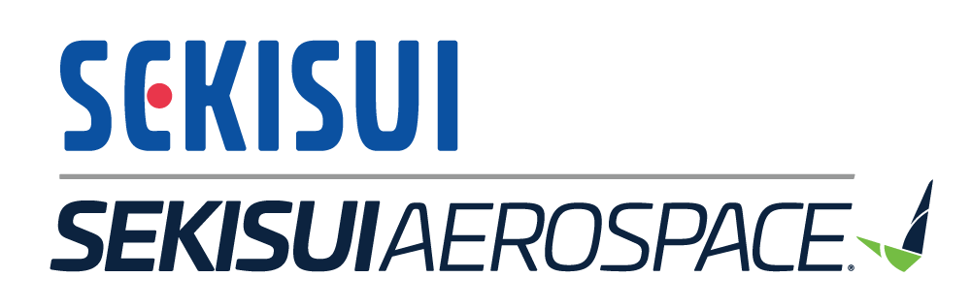
Intern Name: Jimmy Huynh Major: Mechanical Engineering School: University of Washington Business: SEKISUI Aerospace
Industry: Aerospace Manufacturing (NAICS 3364)
WASI Project: Prepreg Waste Reduction

Company Description
SEKISUI Aerospace specializes in the design and manufacture of composite products for the aerospace industry. SEKISUI offers innovative and cost-effective solutions for aerospace structures, systems, and interiors, catering to a wide range of customers.
SEKISUI Aerospace, a part of the SEKISUI Chemical Group, has over 700 employees spread across three sites in Renton and Sumner, Washington, and Orange City, Iowa.

Incentives for Change
SEKISUI actively prioritizes social and environmental value by decreasing their material use and process costs, thus lowering their environmental impact. These goals align with their parent company, SEKISUI Chemical, which has been selected as a 2023 Global 100 Sustainable Corporations in the World for the sixth consecutive year.

Project Description

Prepreg scrap reduction and ply optimization projects
The prepreg scrap reduction project focused on understanding and minimizing waste generation throughout the manufacturing process. Prepreg materials are fibers that are preimpregnated with resins or epoxy. The prepreg is cured after it is formed onto a part. By tracking the journey of prepreg material from purchase to assembly, key areas of waste production were identified: kit cutting, layup, breakout, and trimming. This project had two phases: layup and ply optimization.
The layup phase was identified as the primary source of scrap waste in the manufacturing process, with
35.22 percent of material lost to scrap. The ply optimization project aimed to enhance production efficiency and reduce waste by redesigning prepreg kits for improved fit. This project targeted kits that were high-rate production parts or had long production times. The goal was to optimize the kits to better match the final parts’ shapes and minimize excess prepreg scrap trimmed from parts during lamination.

Optimizing the prepreg kit for one part resulted in a 29 percent part-weight reduction, in addition to a 31 percent material-length reduction during the kit cutting process. An optimized kit reduces the need for laminators to make additional cuts, which wastes both time and material.

Hazardous waste reduction project
The extremely hazardous waste (EHW) identification and reduction project aimed to address the environmental and cost implications of potentially hazardous dust generated from the fill and fare process. The project focused on communication with suppliers to determine the chemical composition of prepreg materials, including halogenated organic compounds (HOC), and explored exemptions from the EHW designation.
Challenges included proprietary information constraints and supplier communication difficulties. The project led to the creation of a hazard matrix that detailed supplier formulation information, lab results, and exemption qualifications. These efforts could reduce disposal costs up to $58,000 annually and redesignate nearly 16,000 pounds of dangerous waste.

Recommendations

Prepreg scrap reduction and ply optimization projects
Applying the ply optimizing process to more kits could improve manufacturing efficiency. The amount of material used per part will be reduced, and less scrap will be cut off the part during the lamination process.
Improved training will minimize the number of defective parts by improving lamination habits and optimizing the entire layup process. During this training, experienced laminators show the basics of the layup process, providing guidance and tricks of the trade.
Constant review of the process can help identify pain points, where ply optimization can improve part production efficiency and reduce waste. Other sources of prepreg waste should also be investigated, specifically the expired material rolls in storage and scrapped parts throughout the manufacturing process. Waste of expired materials can be minimized by improving how materials are inventoried, preventing overstocking of unusable material.

Hazardous waste reduction project
Continue communications with material suppliers. Verify that all prepreg materials on site qualify for the polymerization exemption, or obtain manufacturer information to verify the material would not be persistent dangerous waste. Ensure any new prepreg materials also meet the criteria.

Estimated annual effects from implementing recommended P2 action

Recommended P2 actions | Savings per roll ($) | Total savings ($) | Hazardous materials reduction (lbs) | Hazardous waste reduction (lbs)
Ply Optimization – Pony Kit only | 460 | 4,400  (3,800-  5,800) | 1,200  (800-1,600) | 1,200  (800-1,600)
Ply Optimization – all parts | 460 | 12,650  (8,300-  17,000) | 3,500  (2,300-4,700) | 3,500  (2,300-4,700)
Reclassify HHW –  Polymerization  exemption | - | 58,000 | - | 16,000

